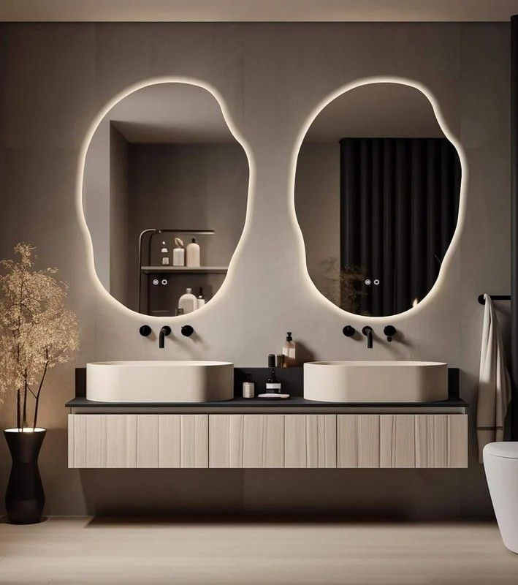**Redefine Your Bathroom with Stylish & Functional Mirrors**

The bathroom is no longer just a functional space — it’s a place for relaxation, self-care, and daily rituals. Our premium **Bathroom Mirrors** are designed to bring both utility and elegance to this intimate part of your home. With thoughtfully chosen styles that suit both small and spacious bathrooms, these mirrors offer the perfect combination of practicality and aesthetic charm.

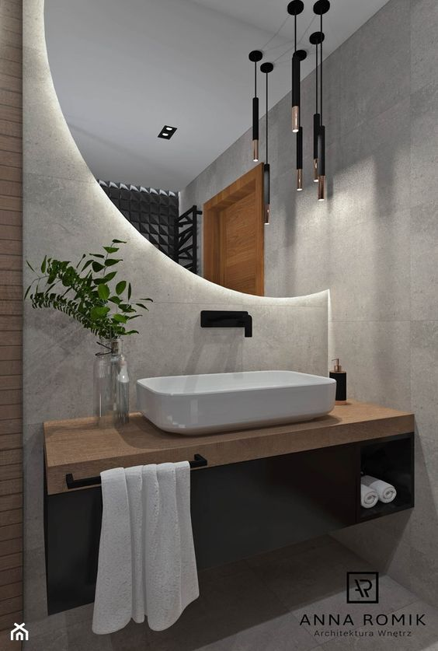Our collection includes a variety of mirror types: anti-fog LED mirrors, minimalist frameless panels, classic oval shapes, and modern geometric designs — each crafted with precision to enhance your space. These mirrors not only help you start your day with clarity and confidence but also uplift the overall look of your bathroom by reflecting light and making it feel more open and luxurious.

Made with moisture-resistant materials and high-quality reflective surfaces, our bathroom mirrors are built to last even in humid environments. Easy to clean and effortless to install, they are the ideal choice for anyone seeking functionality without compromising on design.

Upgrade your bathroom with a mirror that’s as smart and beautiful as your daily routine deserves.